Face masks
What you can and cannot wear
Accessible

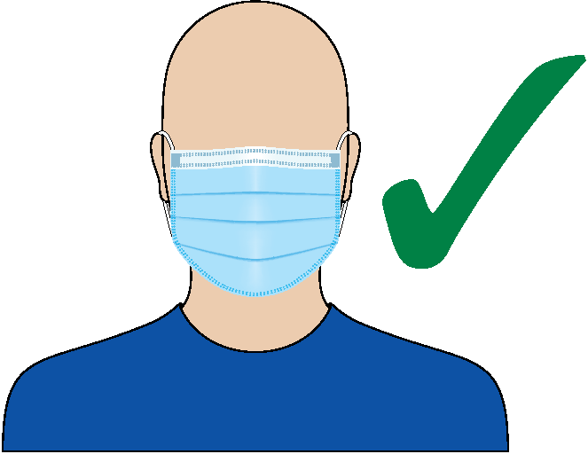
A fitted mask needs to be worn covering both your nose and mouth.
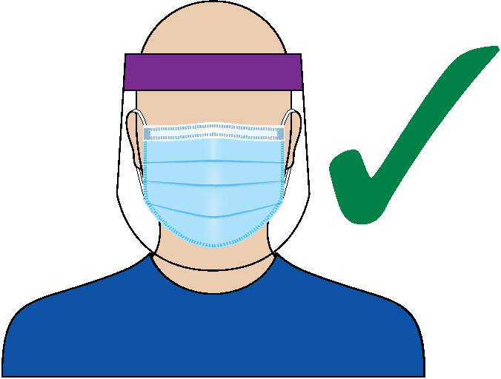
You can wear a face shield with a fitted face mask.
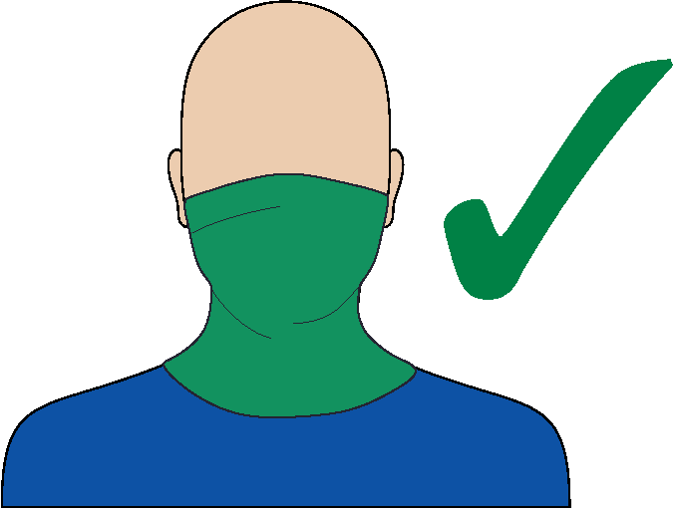
A fitted snood, Buff® or gaiter can be worn covering both your nose and mouth.

There are two types of face masks you can wear:
cloth masks and surgical masks.
- Cloth masks are made of washable fabric and can be washed and re-used.
- Surgical masks are single-use masks and cannot be washed or re-used.

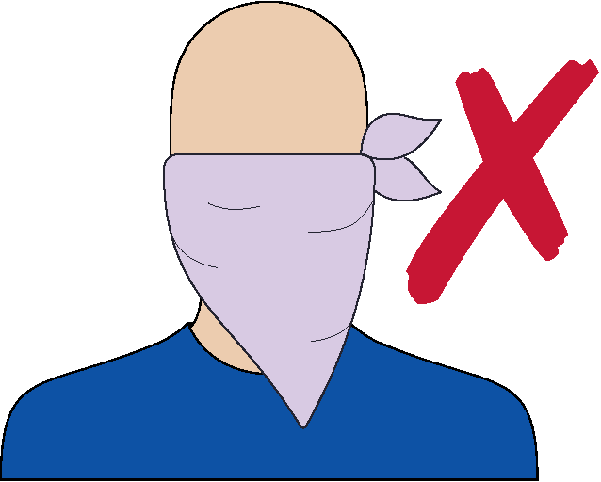
You cannot wear a bandana or scarf on its own.
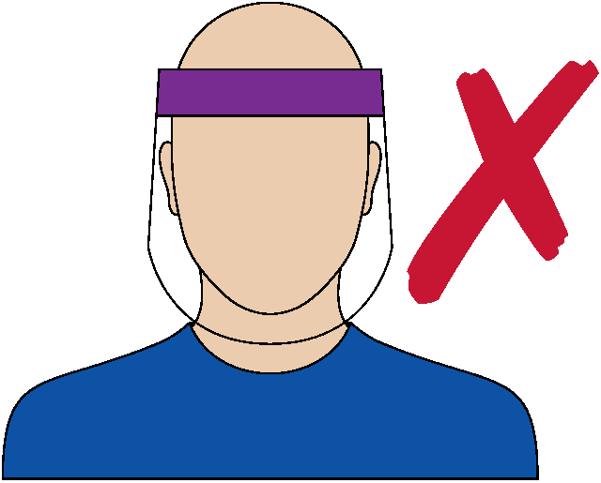
You cannot wear a face shield on its own.
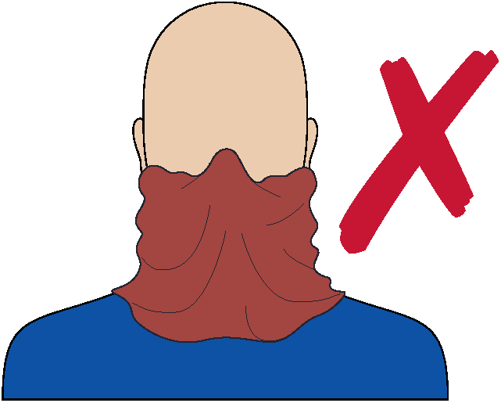
You cannot wear a loose snood, Buff® or gaiter on its own.

How to put your mask on
Image | Step
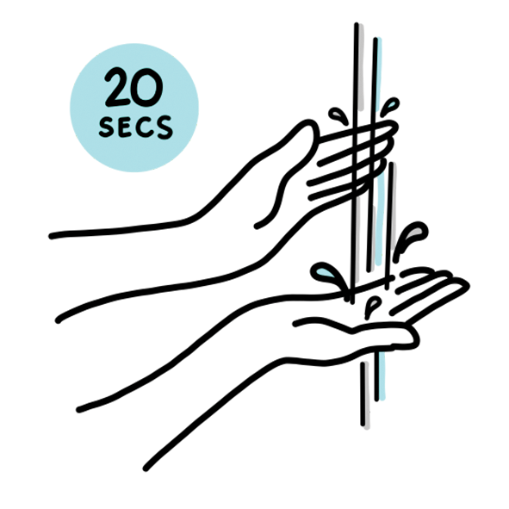 | Step 1: Wash your hands with soap and water before putting on the mask.
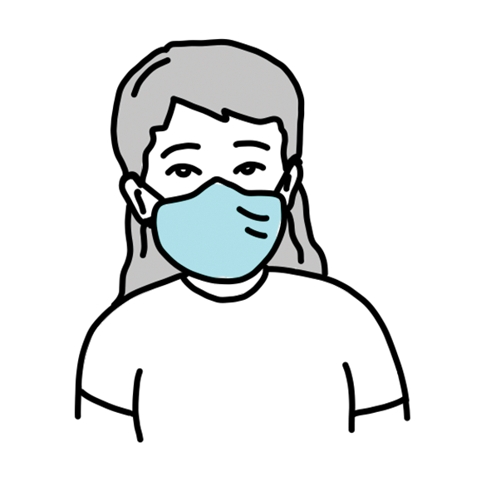 | Step 2: Make sure the mask covers your nose and mouth and fits snugly under your chin, over the bridge of your nose and against the sides of your face.
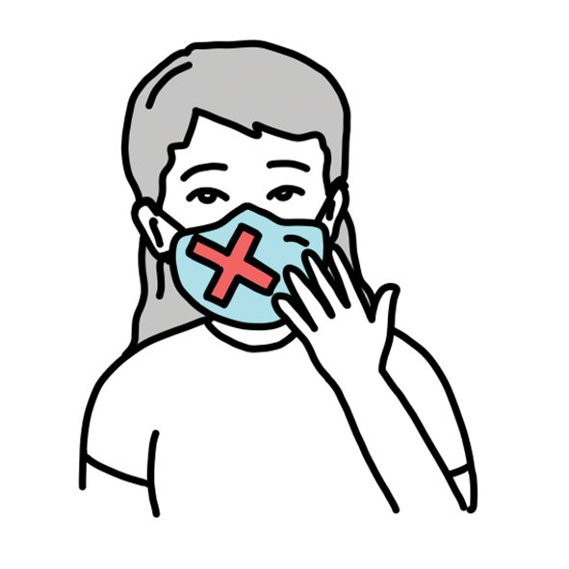 | Do not touch the front of the mask while wearing it.  Step 3: If you do touch the mask, wash your hands with soap and water or sanitise your hands immediately.  Do not allow the mask to hang around your neck.

How to take your mask off
Image | Step
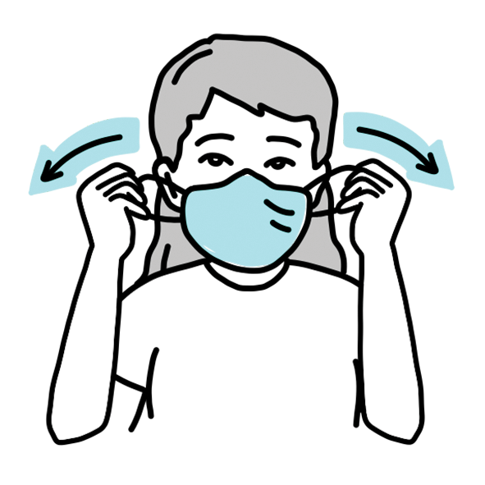 | Step 1: To remove the mask, wash your hands with soap and water or sanitise your hands first.  Step 2: Carefully remove your mask by grasping the ear loops or untying the ties. For masks with a pair of ties, unfasten the bottom one first, then the top one.
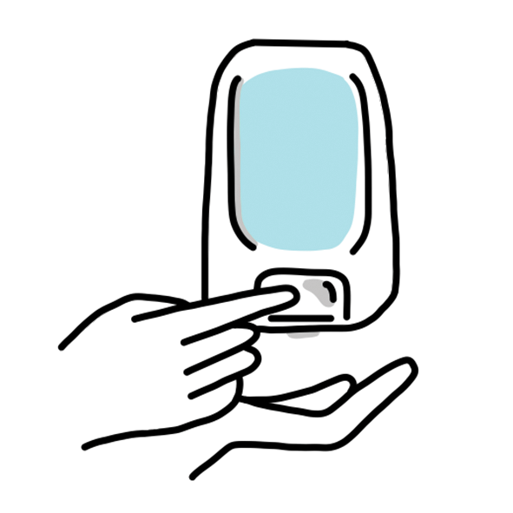 | Step 3: If your mask has filters, remove them and throw them away.  Step 4: Fold the mask and put it directly into the laundry or into a disposable or washable bag for laundering. Single-use surgical masks should be disposed of responsibly and not be re-used.  Step 5: Wash your hands with soap and water or sanitise your hands after removing the mask.
To receive this document in another format email the Department of Health and Human Services <COVID-19@dhhs.vic.gov.au>
Authorised and published by the Victorian Government, 1 Treasury Place, Melbourne. (2001628)
© State of Victoria, Australia, Department of Health and Human Services,
9 October V8 2020 (accessible 12 October 2020).
Available at: DHHS.vic – Face masks: whole of Victoria <https://www.dhhs.vic.gov.au/face-masks-vic-covid-19>

